**How sales affect the**

**Inventory Management in Amazon.inc**

Submitted

by

**KEVIN ALLEN T D (192224272)**

Guided by

Dr. RAJASEKARAN. A

Associate Professor

Department of AI&ML

**Department of Computer Science and Engineering,**

**Saveetha School of Engineering, SIMATS**

**Thandalam, Chennai**

**October – 2023**



**I. PROBLEM STATEMENT**

From analysing the data of **Amazon.inc** we came to know about the problems faced by amazon in the field of inventory management. I came to know that the problems raised in inventory management control is mainly dependent on the sales volume of the company over a period of time. Some of the problems faced are

* Which month has the least number of sales?
* Which month had large number of sales?
* How much the company lost over the years?

The reason why the number of sales affect the inventory management is,

**1.1 Stockouts and Overstocking:** Inadequate inventory levels due to unexpected high sales can result in stockouts, which can harm customer satisfaction and sales. On the other hand, excessive inventory due to low sales can lead to overstocking, tying up capital and increasing holding costs.

**1.2 High Sales:** High sales levels may necessitate holding more inventory, increasing carrying costs. Effective inventory management is required to balance the costs of carrying inventory with the benefits of being able to meet customer demand.

**1.3 Seasonal Adjustments:** Many businesses experience seasonality in sales. Inventory management needs to account for these fluctuations to ensure that inventory levels are aligned with expected sales during different times of the year.

**II. DATASET ANALYSIS**

|  |  |  |
| --- | --- | --- |
| Year | Revenue ($bn)  From sales | Profit margin ($bn) from sales |
| 2005 | 8.4 | 0.35 |
| 2006 | 10.7 | 0.19 |
| 2007 | 14.8 | 0.47 |
| 2008 | 19.1 | 0.64 |
| 2009 | 24.5 | 0.9 |
| 2010 | 34.2 | 1.15 |
| 2011 | 48 | 0.63 |
| 2012 | 61 | -0.03 |
| 2013 | 74.4 | -0.84 |
| 2014 | 88.9 | -0.24 |
| 2015 | 107 | 0.59 |
| 2016 | 135.9 | 2.37 |
| 2017 | 177.8 | 3.03 |
| 2018 | 232.8 | 10.07 |
| 2019 | 280.5 | 11.58 |
| 2020 | 386 | 21.33 |
| 2021 | 470.8 | 33.36 |
| 2022 | 513.9 | -2.72 |
| **Table 1:** Revenue and Profit Generated in Billions (Amazon.inc) | | |

**IN AMAZON:**

"Prime Big Deal Days: Everything you need to know about Amazon's 48-hour shopping event. Deloitte. "Deloitte: Holiday Retail Sales Expected to Increase Between 3.5% to 4.6%."

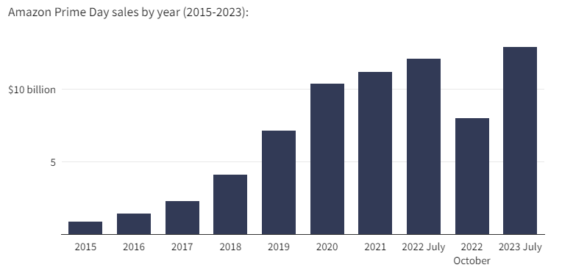

**Fig1:** Amazon prime day sales by year

**III. ENVIRONMENTAL SETUP**

**3.1 Scope:**

* This project is mainly about how the number of sales affect the inventory management in a big companies like amazon.
* It also explains the amount of revenue generated by amazon over a period of years.
* Also, to check whether the sales increased during the holidays or not.

**3.2 Data sources:**

* The data of the total revenue earned and total profit and loss Margins in a year from 2005 to 2022 had been identified and extracted directly from amazon’s website as a CSV file.
* Some data are also collected from the internet sources like Google chrome, etc...,

**3.3 Data Analysis:**

* The data collected is analysed by using the library function pandas in python
* The data is visually analysed as a bar graph, scatter plot, histogram and in many formats to effectively analyse the data
* The analysation is done by comparing the revenue generated by Amazon Over a period of years (i.e.,2002 – 2022)

**IV. DATA FLOW DIAGRAM**

**INVENTORY MANAGEMENT**

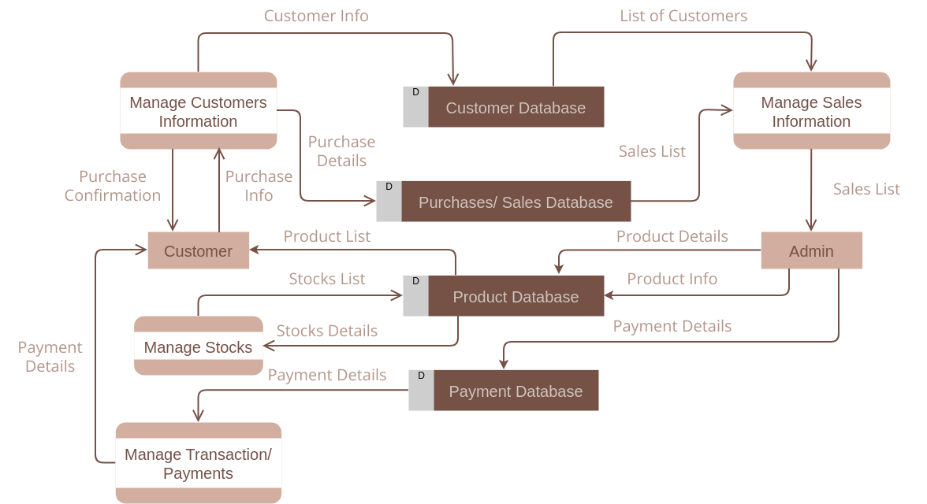

**Fig2:** Flow diagram on inventory management

**SALES MANAGEMENT**

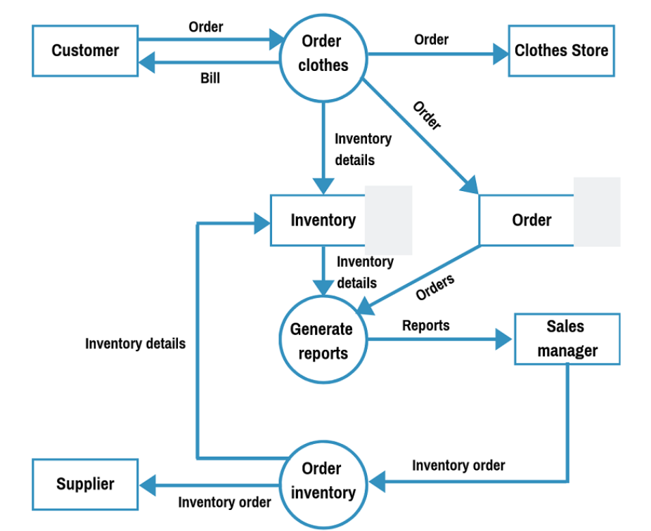

**Fig3:** Flow diagram on sales management

**V. CODE SKELETON**

1. import pandas as pd
2. df=pd.read_csv (r"C:/Users/KevinAllen/OneDrive/Desktop/
3. Amazon Data.csv")
4. df=df.set_index('Year')
5. df

**DATASET**

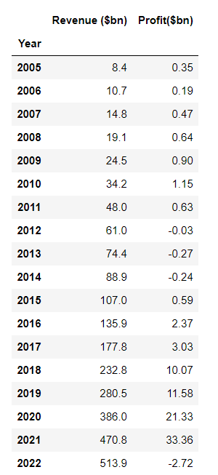

**Table 2:** a dataset table representing Revenue and Profit Generated in Billions (Amazon.inc)

**5.1 TO ANALYSE THE DATA USING GRAPH**

import pandas as pd

import matplotlib.pylab as plt

df=pd.read_csv(r"C:/Users/Kevin Allen/OneDrive/Desktop/Amazon Data.csv")

df=df.set_index('Year')

plt.figure(figsize=(18,10))

plt.plot(df.index,df['Revenue($bn)'],color='green',marker='o',label='Revenue ($bn)')

plt.plot(df.index,df['Profit($bn)'],color='red',marker='o',label='Profit($bn)')

plt.title('Revenue and Profit Generated in Billions',fontsize=18)

plt.ylabel('Amount in $bn',fontsize=18)

plt.xlabel('Year',fontsize=18)

plt.grid()

plt.legend(fontsize=18)

plt.show()

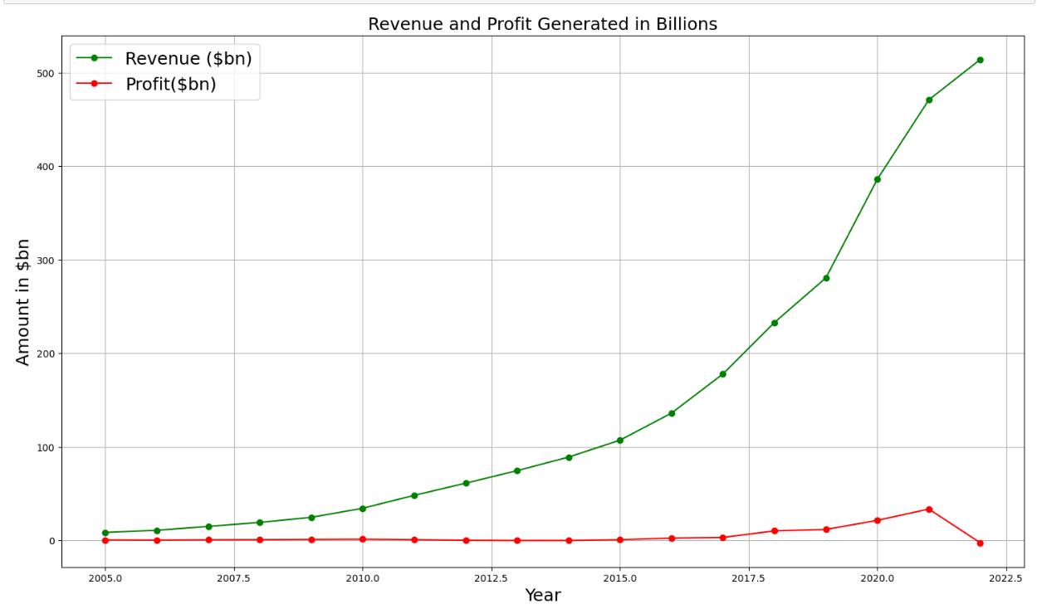

**Fig4:** a graph of Revenue and Profit Generated in Billions (Amazon.inc)

**VI. RESULT ANALYSIS**

**Revenue and Profit Generated in Billions**

**(Amazon.inc)**

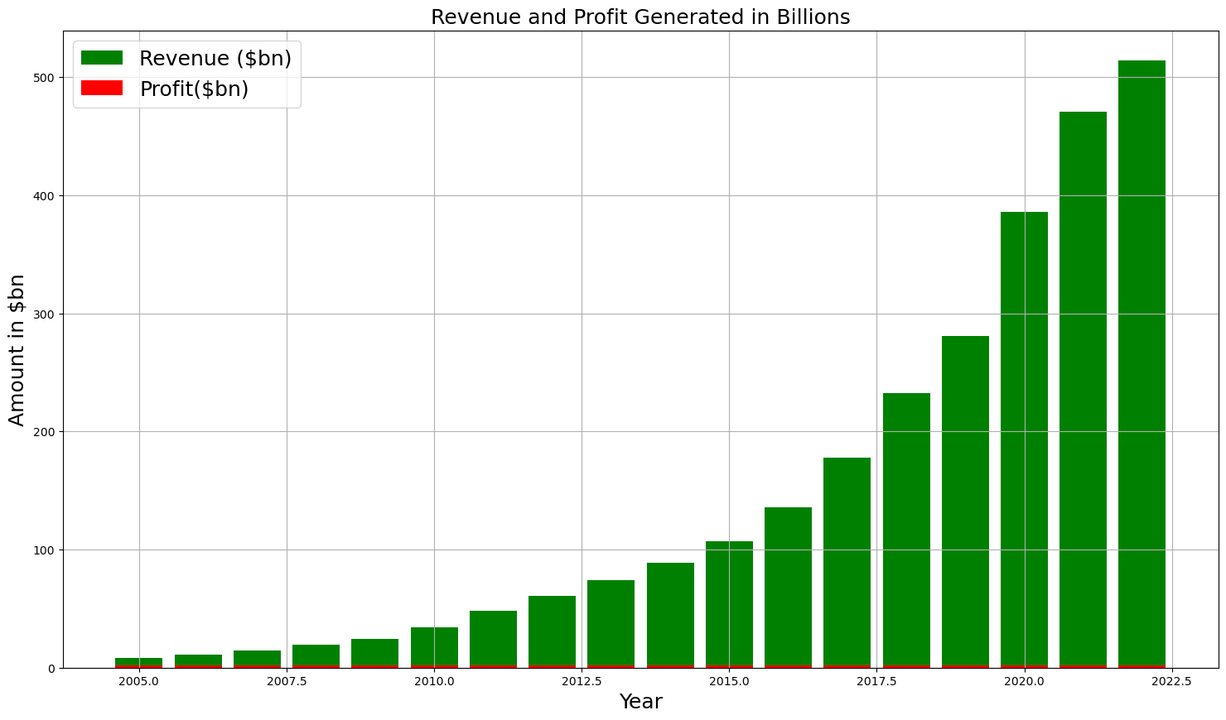

**Fig5:** a bar graph of Revenue and Profit Generated in Billions (Amazon.inc)

**Sales In Normal Days VS Holidays**

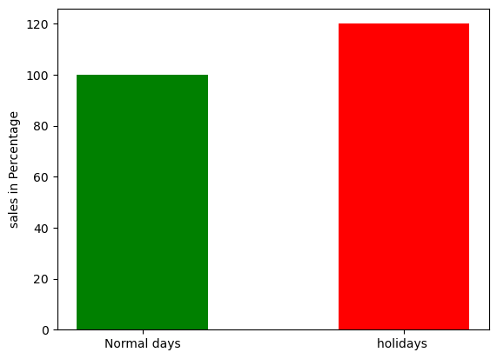

**Fig6:** The above data is the analysis of the sales in normal days and in holidays a recent survey in global market says that the sales increase by 14 to 17%

**VII. CONCLUSION**

* The problem statements have been solved using the data analysis and These graphs are analyzed effectively.
* By analyzing the graphs, we got accurate answers for our questions.
* From the graph we came to know that the sales amount really affects the inventory management system
* In the year 2022 amazon.inc generated the most amount of revenue of 514 billion dollars and the year 2005 has generated the least amount of revenue that is 0.35 billion dollars
* The sales in holidays are high compared to the normal days
* In conclusion, sales play a pivotal role in shaping Amazon's inventory management strategies. The ability to accurately predict, meet, and even drive consumer demand through effective inventory management has been a key factor in Amazon's dominance in the e-commerce space. As sales continue to grow, so does the complexity of inventory management, necessitating continuous innovation and optimization.